 

**SARDAR VALLABHBHAI PATEL INSTITUTE OF TECHNOLOGY**

A REPORT ON

**HAND GESTURED ARDUINO ROBO**

Under the subject of

**DESIGN ENGINEERING-2A**

**B.E. III, Semester – V**

**(COMPUTER ENGINEERING)**

Submitted by:

Group:

|  |  |  |
| --- | --- | --- |
| Sr. No. | Name of Student | Enrollment No. |
| 1 | Samruddhi Landge | 150410107037 |
| 2. | Krishna Mayavat | 150410107041 |
| 3. | Meet Soni | 150410107042 |
| 4. | Mitali Maniyar | 150410107048 |

Assistant Prof. Tejas Bhatt

(Faculty Guide)

Prof. Bijal Talati

(Head of the Department)

Academic year

(2017-2018)

**SARDAR VALLABHBHAI PATEL INSTITUTE OF TECHNOLOGY**

**VASAD–388306, GUJARAT–INDIA**

***Certificate***



Date:

This is to certify that students with En.no. 150410107037, 150410107041, 150410107042, 150410107048 Of program **Computer Engineering** [Third Year, 5th Semester] have satisfactorily completed their term work in course **Design Engineering-2A[2150001]** for the term ending in **November 2017.**

**Staff In-Charge Head of Department**

**Mr Tejas Bhatt Ms. B. J. Talati**

Assistant Professor Assistant Professor

C.E. Department C.E. Department

**CONTENT**

1. **Introduction**……………………………………………………………....4
2. **System Requirement Specification**……………………………………………………………….4
   1. Introduction ………………………………..………………… ……4
   2. Product Perspective……………………………………………..5
   3. System Requirements…………………………………………..5
3. **Diagrams**………………………………………………………................7
   1. Use Case ………………………………..……………………………...7
   2. Data Flow Diagram ………………………………………………...9
   3. E-R or class Diagram…………………………………………..….10
   4. Activity Diagram…………………………………………………….11
   5. Sequence Diagram.....................................................12
4. **Comparison with existing System** ……………………………..……12
5. **Conclusion**……………………………………………………………………….…….12

**1.INTRODUCTION**

Our domain area is Internet of Things. We have specifically developed our device to search lost object to make people’s life easier. We have also considered many problems solving examples. In product development canvas we have given the description of our product, its specification, function, features, purpose, components.

In reverse engineering we have researched on our product and gained much knowledge about it. We have also discussed the technical aspects of our project, redesigned our idea and worked on the improved design.

We took the feedback analysis which helped us know the customer’s point of view and tried to solve their queries.

We also made the Learning Need Matrix (LNM) canvas which also helped improving our product.

**2. SYSTEM REQUIREMENT SPECIFICATION**

**2.1 INTRODUCTION**

Our project is Hand Gestured Arduino Robo in which we are using an Arduino microcontroller. Our domain area is robotics and automation. Since today’s world is the world of technology, many people are mainly dependent on automated things. We have specifically selected to automate the regions such as mines in which human have to risk their lives in terrible and intense hot temperature.

Therefore this project is mainly made by the point to automate such areas in which there is risk to human lives such as coal or gold mines where temperatures are too high and no proper oxygen levels are there.

To implement this on a lower scale we would be using Accelerometer, RF transmitter and receiver technology. Also an arm gripper is used to lift some things. Other than this there are also many other components like using a camera and a torch or led etc.

**2.2 PRODUCT PERSPECTIVE**

The main perspective of our project is to automate the areas where human lives are endangered. This product is made with focusing the mines in which the human lives are affected due to high temperature and heat. This product can also be used in farming to help the farmers ease their work.

Another use of this product can be made in the medical field for surgeries.

**2.3 SYSTEM REQUIREMENTS**

1. **FUNCTIONAL REQUIREMENTS**
2. Making hand gestures to control the car.
3. Accepting data from the accelerometer.
4. And then perform required actions.
5. **NON-FUNCTIONAL REQUIREMENTS**
6. Maintainability: The user is required to control the robo in order to perform the specific tasks.
7. Portability: The robo is portable to carry it from one place another.
8. Usability: This product can be used by the industries or business related works. It can also be used for personal usage like using the robo for home automation. So it can be used for both profit and non-profit organizations.
9. Accuracy: We are making this product on the small scale. So to use this robo on larger scale more accurate peripherals and microcontroller or microprocessor is needed.
10. Constraints: The product has few cons also. This robo cannot be used in water and wet surfaces. Also temperature constraints are there.
11. **Feasibility study**
12. **Technical feasibility**

Gripper should pick things in efficient manner with respect to command given by arduino. Troubleshooting should be convenient to the user.

1. **Economical feasibility**

Cost incurred software development to produce long term gains for an organisation.

Product cost should be optimised.

1. **Schedule feasibility**

Operation time should be minimum. Hardware complexity, quality and estimate amount of efforts should be minimum.

1. **Operational feasibility**

Determines whether the solution suggested by the software development team is acceptable.

Analysis weather user will adapt to arduino interface.

**3. DIAGRAMS**

**3.1 USE-CASE:**

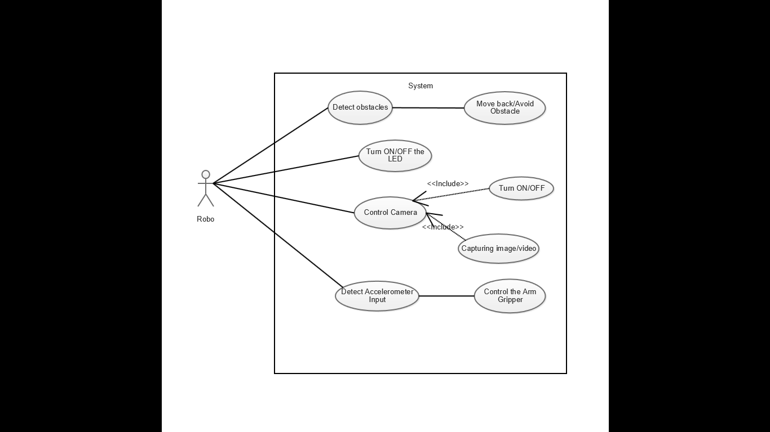

**USE-CASE 1**

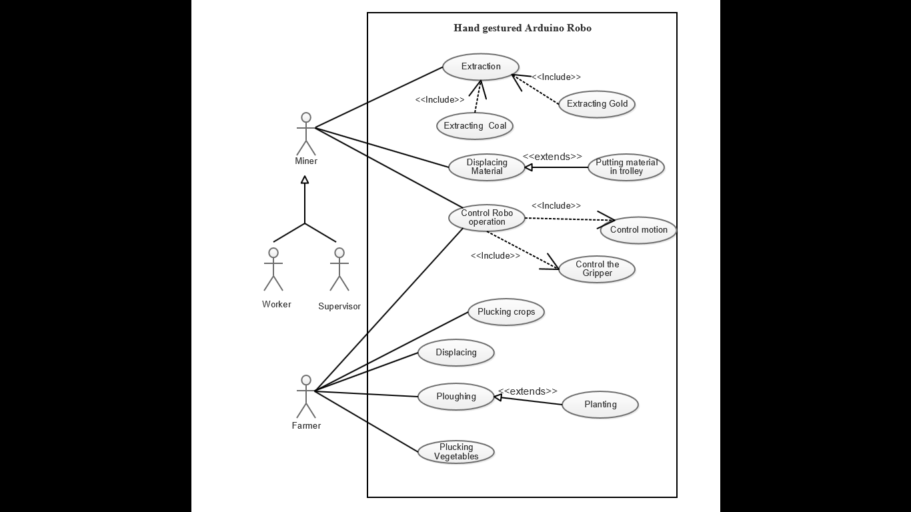

**USE-CASE 2**

**3.2 DATA FLOW DIAGRAM**

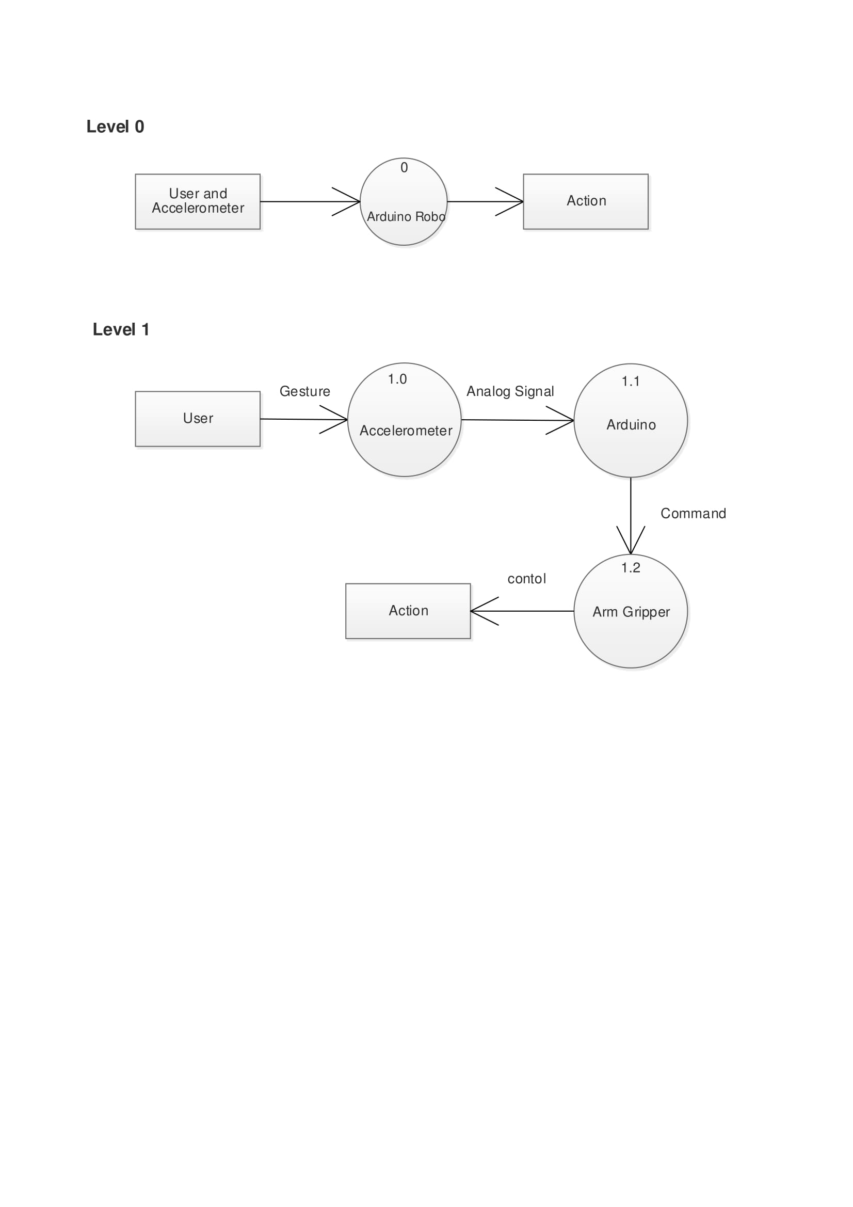

**3.2 E-R DIAGRAM**

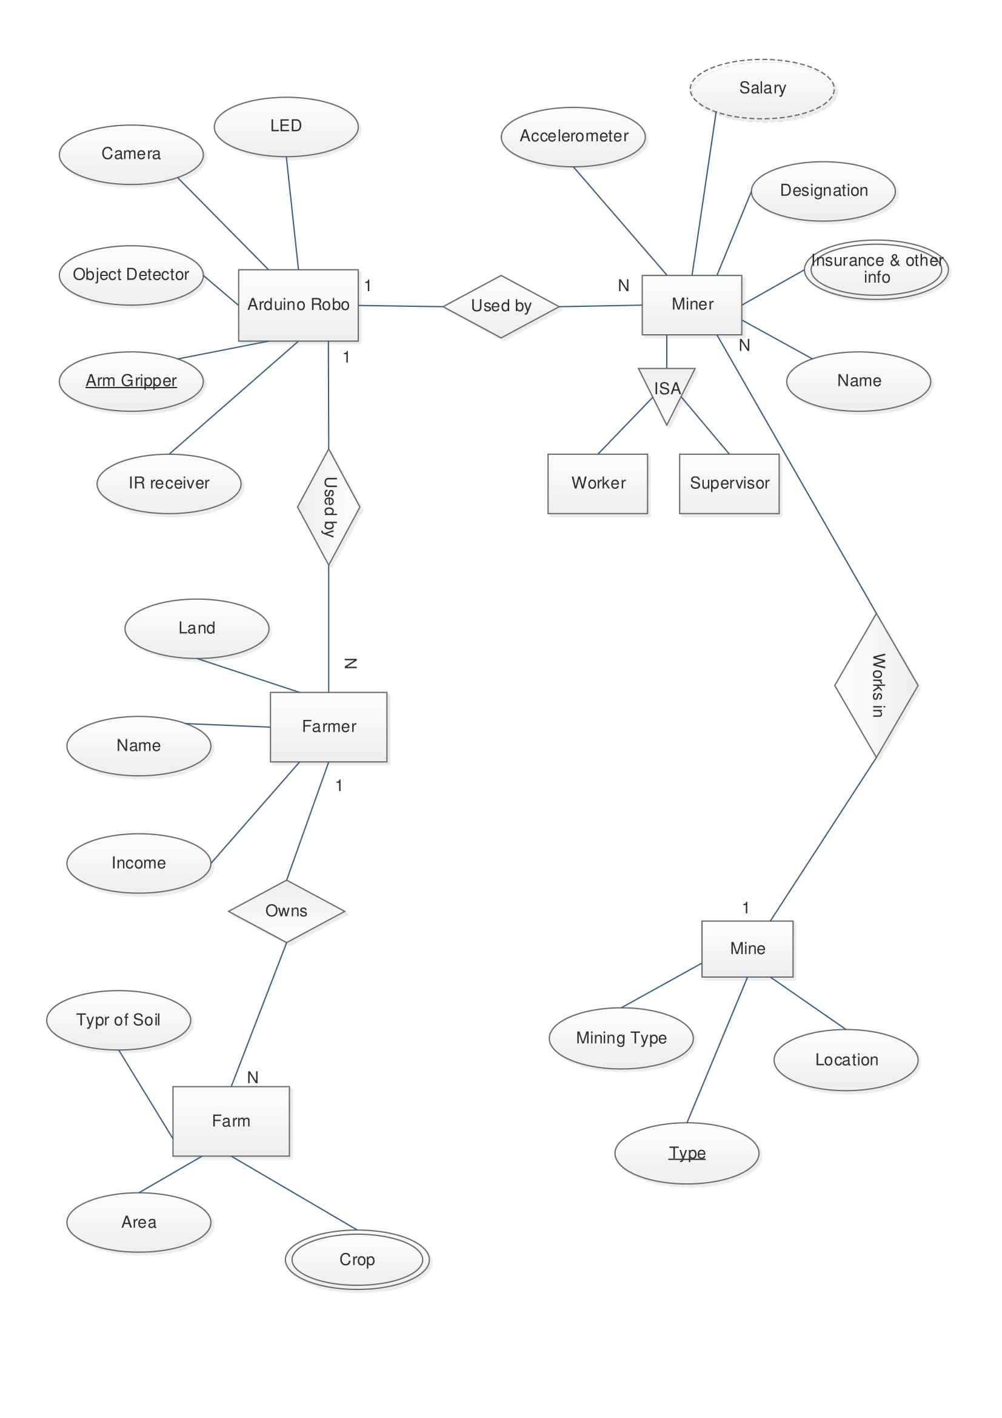

**3.3 ACTIVITY DIAGRAM**

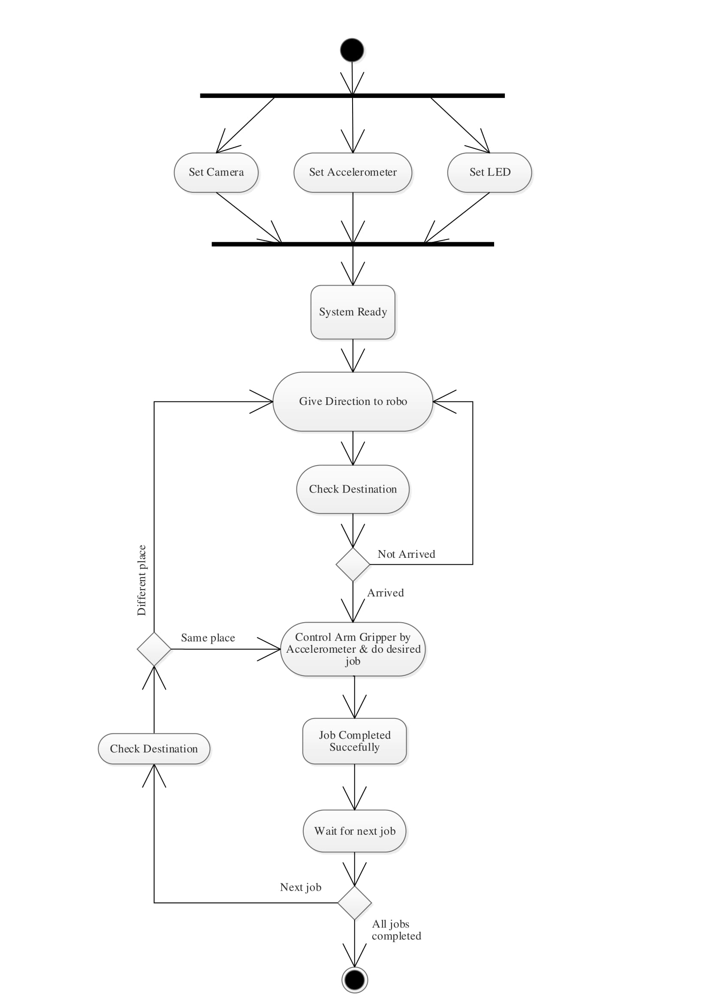

**3.4 SEQUENCE DIAGRAM**

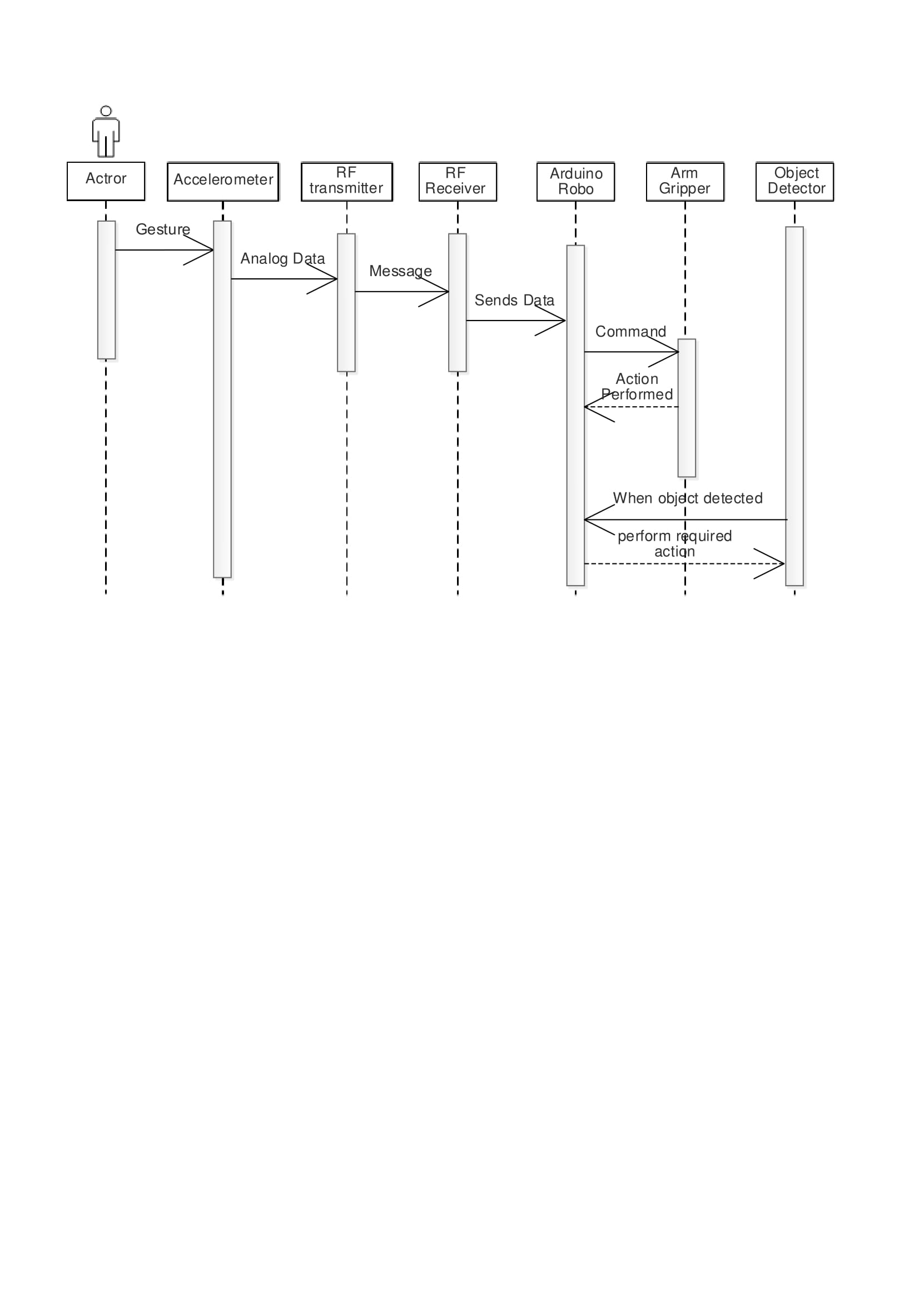**4. COMPARISON WITH EXISTING SYSTEM**

Currently in the market only the machines for displacing objects are available. Our product also gives much more features than just displacing the objects.

Also the technology that we have used is different.

**5. CONCLUSION**

So at the end of this semester we have worked on the diagrams and product perspective and system details of our product. Gained knowledge about the product feasibility. We were able to acquire much more knowledge about our product and applied it in our diagrams.